Hydra

//need to install first

sudo apt-get install hydra

Whoami

//to discover the user

Hostname

//to display the host name

Pwd

Echo $PWD

//linux command prints the current working directory path, starting from the root (/).

* : home directory

W

//command is a built-in tool that allows administrators to view information about users that are currently logged in. This includes their username, where they are logged in from, and what they are currently doing.

W | grep pts

W | grep pts | head -n 1

W | grep pts | head -n 1 | awk ‘{print $8}’

Who

//lets you display the users currently logged in to your UNIX or Linux operating system.

$grep -w yes *

//to search for the word yes in all files

$grep -i yes *

//to search all the word yes, but also ignore the upper case

$grep -r yes *

//include all the subdirectories in the search

$grep -l yes *

//to list all the matching file that contains yes

$grep -c yes *

//to see the number of matching files containing yes

Echo $SHELL

Fg

//command running in background

Ls - al

Ls -l - h

-ls -lha

Ls -alh

Ls -alh /home

Cd /home

/home# adduser “//name”

Passwd “//name of user”

//user vin pw: user2

/user cent pw: centos

Echo “//new passwd” | passwd -stnid “//user name”

**in exam**

Shutdown -h +10

//-h means hold

//+10 means, 10 minutes later

**force delete all**

Rm -rf *

//rm : remove

// -r : recursive

// -f : force

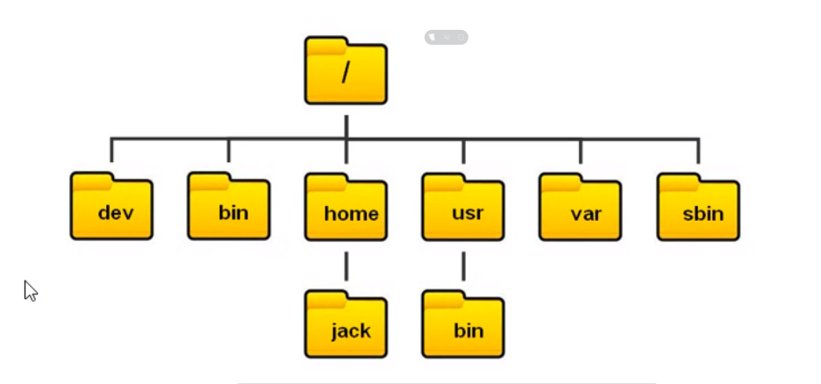

//the folder sbin is the data for super user

//usr : unit resource, uses to store 3rd party software

//etc : not visible, but used to store password, and private information

Cat ip forward

Echo 1 > /pric/sys/net/ipv4/ip_forward

//use to provide hotspot

Echo 0 > /pric/sys/net/ipv4/ip_forward

//turn of hotspot